Abstract
Since its introduction in 1998, Real-Time Location System (RTLS), also known as Indoor Positioning System (IPS), has gained popularity in the technology industry because of its diversified applications and usefulness in people’s daily lives. RTLS is widely accepted and applied in sectors such as supply chain management and logistics, health care and retail. RTLS, enabled by wireless network signals, allows us to detect the exact location of various objects within a closed area in real time. In this paper, we analyze signal strength received from multiple access points to a handheld scanning device to form distinctive clusters of access points based on their positions on a given floor plan. For this purpose, we perform both an unweighted and weighted k-nearest neighbors (k-NN) analysis. Finally, the developed models are evaluated and compared based on the resulted output.

Introduction
A Real-Time Location System (RTLS) is used for the precise positioning of a person or object in real time. This is done via a continuous communication between the device and the object enabled by a Wi-Fi or local area network. A scanning device is primarily used and the signal strength is analyzed to get the coordinates and the angle which determines the location of the object being tracked. RTLS is widely accepted and applied in sectors such as supply chain management and logistics, health care and retail. RTLS, enabled by wireless network signals, allows us to detect the exact location of various objects within a closed area in real time. For this purpose, we perform both an unweighted and weighted k-nearest neighbors (k-NN) analysis.

Data
There are two separate datasets for our analysis [1]. One dataset holds the offline data and the other holds the online data. The offline dataset is used for training our k-NN models. This dataset contains signal strengths that were measured using a handheld device on a floor of a building at the University of Mannheim. The orientation of the handheld device is also collected. The signal strengths were collected at 8 different orientations in 45-degree increments. The online dataset is used for testing our k-NN models. This dataset contains 60 locations, orientations that were randomly chosen and 110 signal strengths that were measured from each access point [1]. Each data set, offline and online, have the same variables and require the same steps for cleaning.

Figure 1: Data Collection Floor Plan [1].
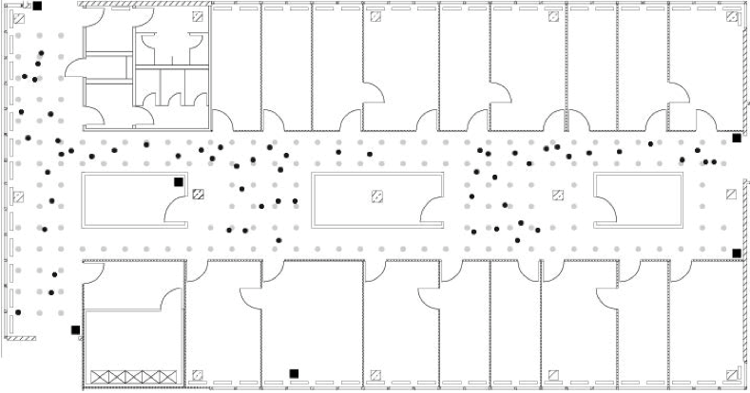

Figure 1 displays the floor plan where the data was collected. The grey dots represent the locations where the offline data were collected. The black dots represent the online data which are randomly selected positions. When the position is unknown, the black squares can be used as a reference point.

Table 1: Raw Data
Variable | Description | Data Type | Example
Time | Timestamp in milliseconds since midnight, January 1, 1970 UTC | Character | 1139643118358
ID | MAC of scan device | Character | 00:02:2D:21:0F:33
Pos | Real position | Character | 0.0,0.0,0.0
Degree | Orientation (in degrees) | Character | 0.0'
MAC of Response1 | MAC Address, signal strength value (dBM), frequency, mode | Character | 00:14:bf:b1:97:8a=-38,2437000000,3
MAC of ReponseN | MAC Address, signal strength value (dBM), frequency, mode | Character | 00:14:bf:b1:97:8a=-38,2437000000,3

The raw data is described in Table 1. However, the format of the raw data is not conducive to performing our exploratory data analysis (EDA) or k-NN model estimation. Therefore, we need to transform and clean our data before we can proceed any further.

First, we look at the Pos variable. There are three values separated by commas. The three values represent the x, y, and z coordinates, respectively. Instead of having the Pos values in one string, we split them and create a column for each coordinate and rename them to be posX, posY and posZ. Since the measurements were only taken horizontally on the floor, we drop the posZ variable. Then, for the variables MAC of Response1 and MAC of ResponseN, we notice that there are four values within each variable. According to the documentation [1], the two variables hold the same information: MAC Address, signal strength, channel and type. We parse these data into separate columns named MAC, Signal, Channel and Type. Type has two different values: 1 (adhoc) and 3 (access point). We are only concerned with the access points, hence we remove the adhoc measurements from the dataset.

The Time variable is a timestamp in milliseconds since midnight, January 1, 1970, UTC. We convert this to a format more readable. First, we create a new column in the dataset called Raw Time, which is the original Time variable divided by 1,000. Then, Raw Time is converted into year-month-day-hours-minutes-seconds and replaces the values in the original Time variable. This way, the data is in a format that we can use to create and analyze our k-NN models. Table 2 describes the format of the clean data.

Table 2: Clean Data
Variable | Description | Data Type | Example
Time | Year-Month-Day-Hours-Minute-Seconds | POSIXt | 2006-02-11 02:31:58
posX | X coordinate of device | Numeric | 20
posY | Y coordinate of device | Numeric | 20
Orientation | Orientation (in degrees) | Numeric | 0
MAC Address | The address of the device | Character | 00:14:bf:b1:97:8a
Signal | Signal strength value (dBM) | Numeric | -38
Channel | MAC Address, signal strength value (dBM), frequency, mode | Character | 2437000000
Raw Time | The timestamp / 1000 | Numeric | 1.139643E+12

Exploratory Data Analysis
In this section, we analyze the variables – orientation, MAC addresses and position of the handheld device – observed from our dataset. Moreover, we also perform a signal strength analysis to study the behavior of the signals from different MAC addresses received by the scanning device.

Theoretically, the orientation can have 8 specific values between 0 and 315 degrees with an increment of 45 degrees, but the measurements are distributed in clusters around the expected values. These observed angles of orientation are then approximated to the nearest of the 8 equidistant angles, as stated. The cumulative distribution function (CDF) of orientation is presented in Figure 2.

Figure 2: Empirical CDF of Orientation for Handheld Device
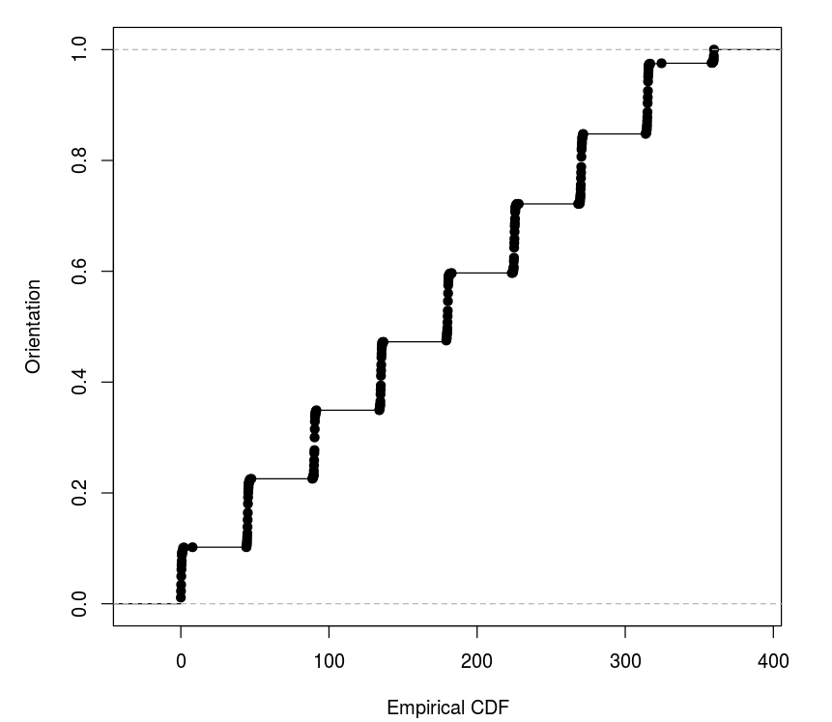

Figure 3 presents a boxplot for the observed orientations around the corresponding approximated values to illustrate the variability within each cluster.

Figure 3: Boxplot of Orientation for Handheld Device
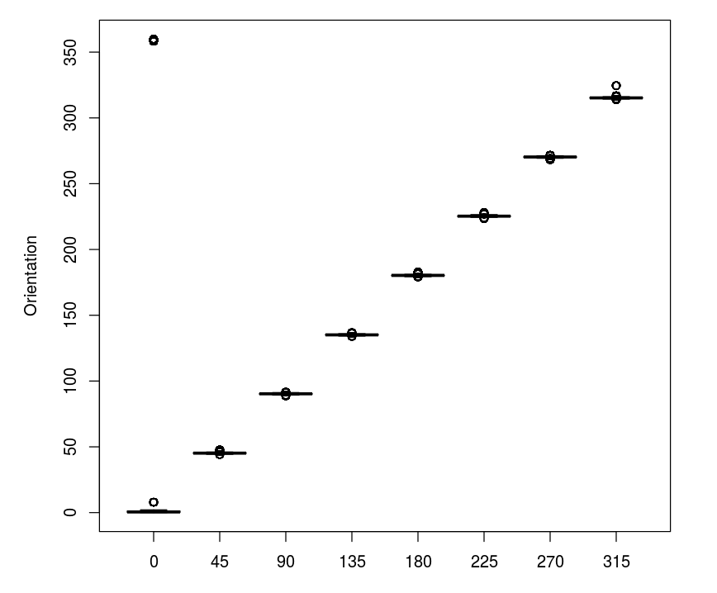

From the data, we observe 12 MAC addresses and 8 channels which contradicts the documentation’s assumption of a one-to-one mapping between MAC addresses and channels. For further analysis, we study the counts of observations for all MAC addresses (Table 3).

Table 3: Frequency of MAC Addresses
MAC Address | Count
00:04:0e:5c:23:fc | 418
00:0f:a3:39:dd:cd | 145,619
00:0f:a3:39:e0:4b | 43,508
00:0f:a3:39:e1:c0 | 145,862
00:0f:a3:39:e2:10 | 19,162
00:14:bf:3b:c7:c6 | 126,529
00:14:bf:b1:97:81 | 120,339
00:14:bf:b1:97:8a | 132,962
00:14:bf:b1:97:8d | 121,325
00:14:bf:b1:97:90 | 122,315
00:30:bd:f8:7f:c5 | 301
00:e0:63:82:8b:a9 | 103

Since according to the documentation, signals are recorded at 166 grid points, 8 orientations and 110 replications, the highest possible count is 146,080. Given this fact, we observe that only 7 of the 12 MAC addresses have sufficiently large counts and the remaining 5 are not the access points displayed on the map. We observe a one-to-one mapping between MAC addresses and channels with these 7 selected devices. Thus, we only consider these 7 devices for subsequent analysis in this study.

The next step is to explore the position of the handheld device which is determined by the x (posX) and y (posY) coordinates. We see that there are 476 unique combinations of (x, y), out of which 310 show no record of any observations. This results into 166 unique locations where a handheld device position has actually been observed. The first 8 location counts from this set of 166 locations are shown in Table 4.

Table 4: Location Counts
posX | posY | Count
0 | 0 | 5505
1 | 0 | 5505
2 | 0 | 5506
0 | 1 | 5524
1 | 1 | 5543
2 | 1 | 5558
0 | 2 | 5503
1 | 2 | 5564

The signal counts for all 166 unique observed locations on the map are displayed in Figure 4.

Figure 4: Signal counts at 166 Locations
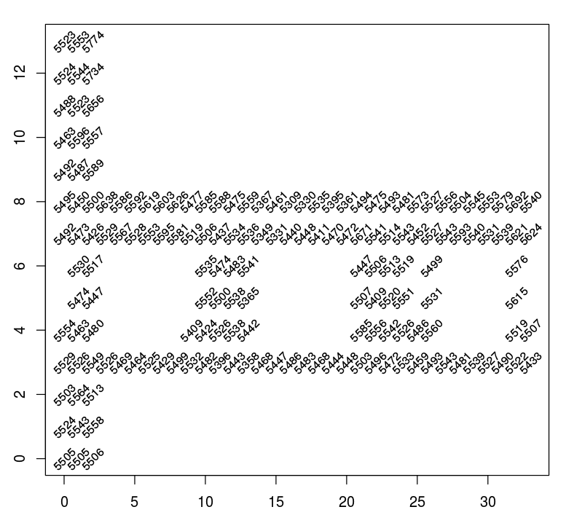

After MAC addresses, orientations and locations are completely determined, we move forward to analyze our variable of interest, signal strength, which is measured in negative values. The lower values indicate weaker signals and the higher indicate stronger ones. Here, our main objective is to investigate whether signal strength is affected by location, orientation and access points and to establish a relationship between signal strength and distance of the access point from the handheld device.

The distributions of signal strength are compared at different orientations and for different access points. For this purpose, we observe in detail the distribution of signal strength based on a specific parameter with other parameters being constant. The box plots in Figure 5 represent signals for one location and the boxes are organized by access point and orientation. We observe that signal strength varies based on orientation for both close and distant access points.

Figure 5: Signal Strength by Orientation for Access Points
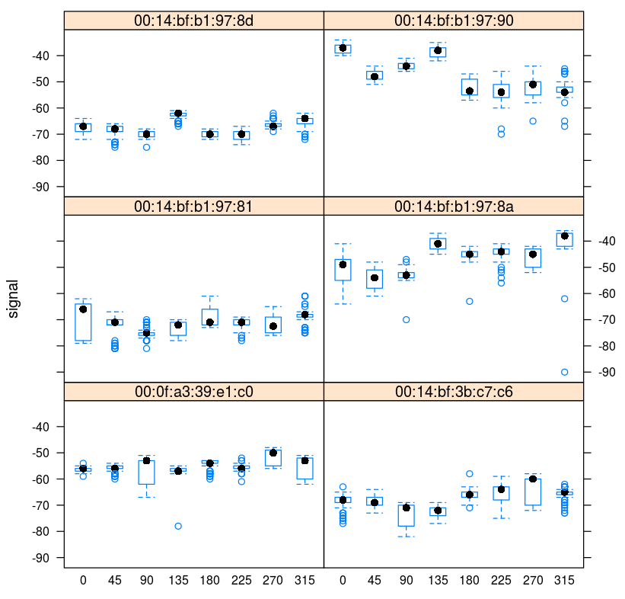

Distribution of signals by orientation at different access points are shown in Figure 6. Most of the signals indicate normal distribution but some exhibit skewed distributions. With different MAC addresses and changes in angles, the center of distribution changes, thereby indicating a strong dependency of signal strength on orientation.

Figure 6: Signal Distribution by Orientation for Access Points
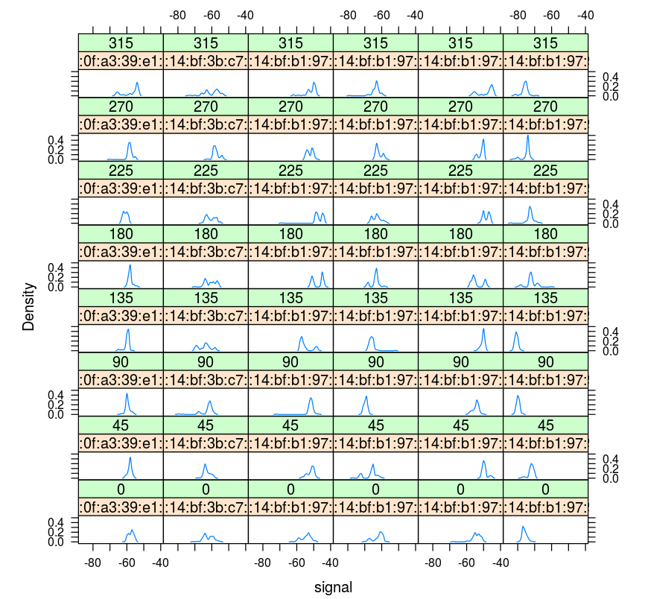

The box plot in Figure 7 clearly indicates that the dispersion in signal strength increases with an increase in the mean signal strength value.

Figure 7: SD of Signal Strength by Average Signal Strength
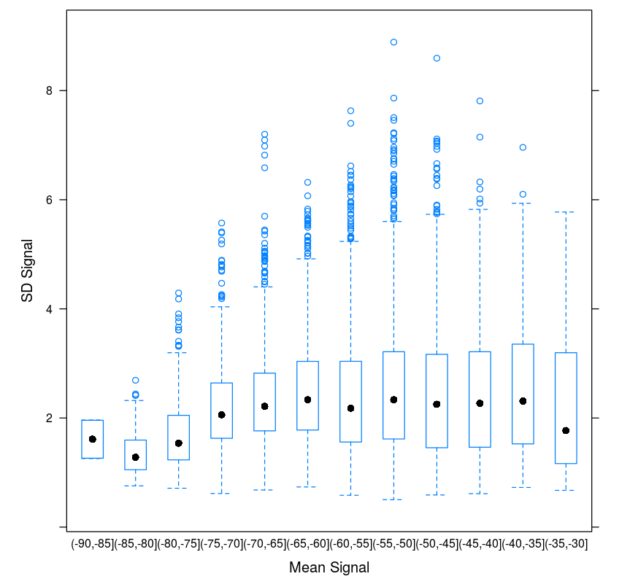

A contour plot (also known as a heat map (Figure 8), similar to a topographical map, visualizes the possible relationships between signal strength and distance of the device from access points. The dark red region in the top left-hand corner of the map indicates the position of the access point. This contour plot enables us to connect MAC addresses to the access points marked on the map.

Figure 8: Contour Map of Access Points
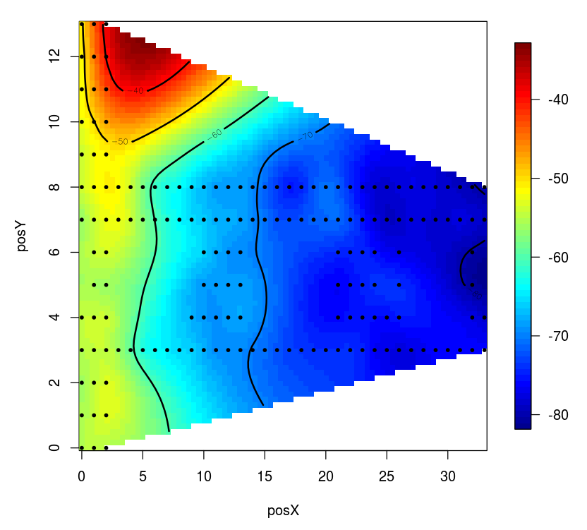

Figure 9 contains scatterplots of signal strength and distance for each combination of orientation and access point. From these plots, we see a clear negative correlation between the stated distance and signal strength.

Figure 9: Signal Strength vs. Distance to Access Point by Orientation
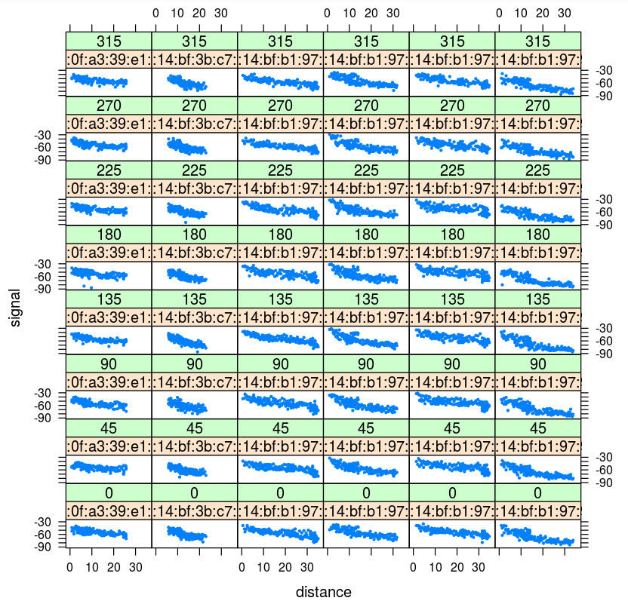

k-Nearest Neighbor Classification
In our analysis, we use a non-parametric machine learning technique called k-nearest neighbors (k-NN) to predict the position of the devices in our test dataset. In the case of k = 1, we estimate the locations of these devices by assigning to each of them the location of a device in our training dataset with the closest signal strength. If k > 1, we predict the new device’s location by an aggregation of the locations of the k devices with the closest signal strength. We measure the closeness in terms of signal strength between a training observation and a test observation by way of the Euclidean metric:
√((S₁ – T₁)² + (S₂ – T₂)² + (S₃ – T₃)² + (S₄ – T₄)² + (S₅ – T₅)² + (S₆ – T₆)²),
where S_{i} is the signal strength measured between a device in the training dataset and the ith access point and T_{i} is the signal strength measured between a device in the test dataset and the ith access point [1].

There are two major types of k-NN algorithms: unweighted and weighted. In the unweighted case, the k nearest neighbors in terms of signal strength distance are each assigned equal weight in estimating the unknown location of a device. That is, the location of the test device is simply an arithmetic average of the (x, y) coordinates of the k closest devices. In the weighted case, the k nearest neighbors are assigned weights that are equal to the reciprocal of its distance to the test device in terms of signal strength. Therefore, training observations with closer signal strength distances are given greater weight in estimating the location of the test observation than are training observations with farther signal strength distances. Formally, the weights of each of the k nearest neighbors are computed as follows:
(1/d_{i})/(sum(1/d_{i})),
where d_{i} is the distance in terms of signal strength between the ith nearest neighbor and the test observation [1]. The case of k = 1 is trivial, as it makes no difference whether the signal strengths are weighted or not. However, in the case of k > 1, the location estimation can be greatly influenced by the weights of the signal strengths.

In this paper, we employ both the unweighted and weighted k-NN methods and compare their performance in accurately predicting the location of the devices in our test dataset.

Model Evaluation and Conclusion
Our weighted algorithm had an accuracy of 2.4%, which was better than our unweighted algorithm.

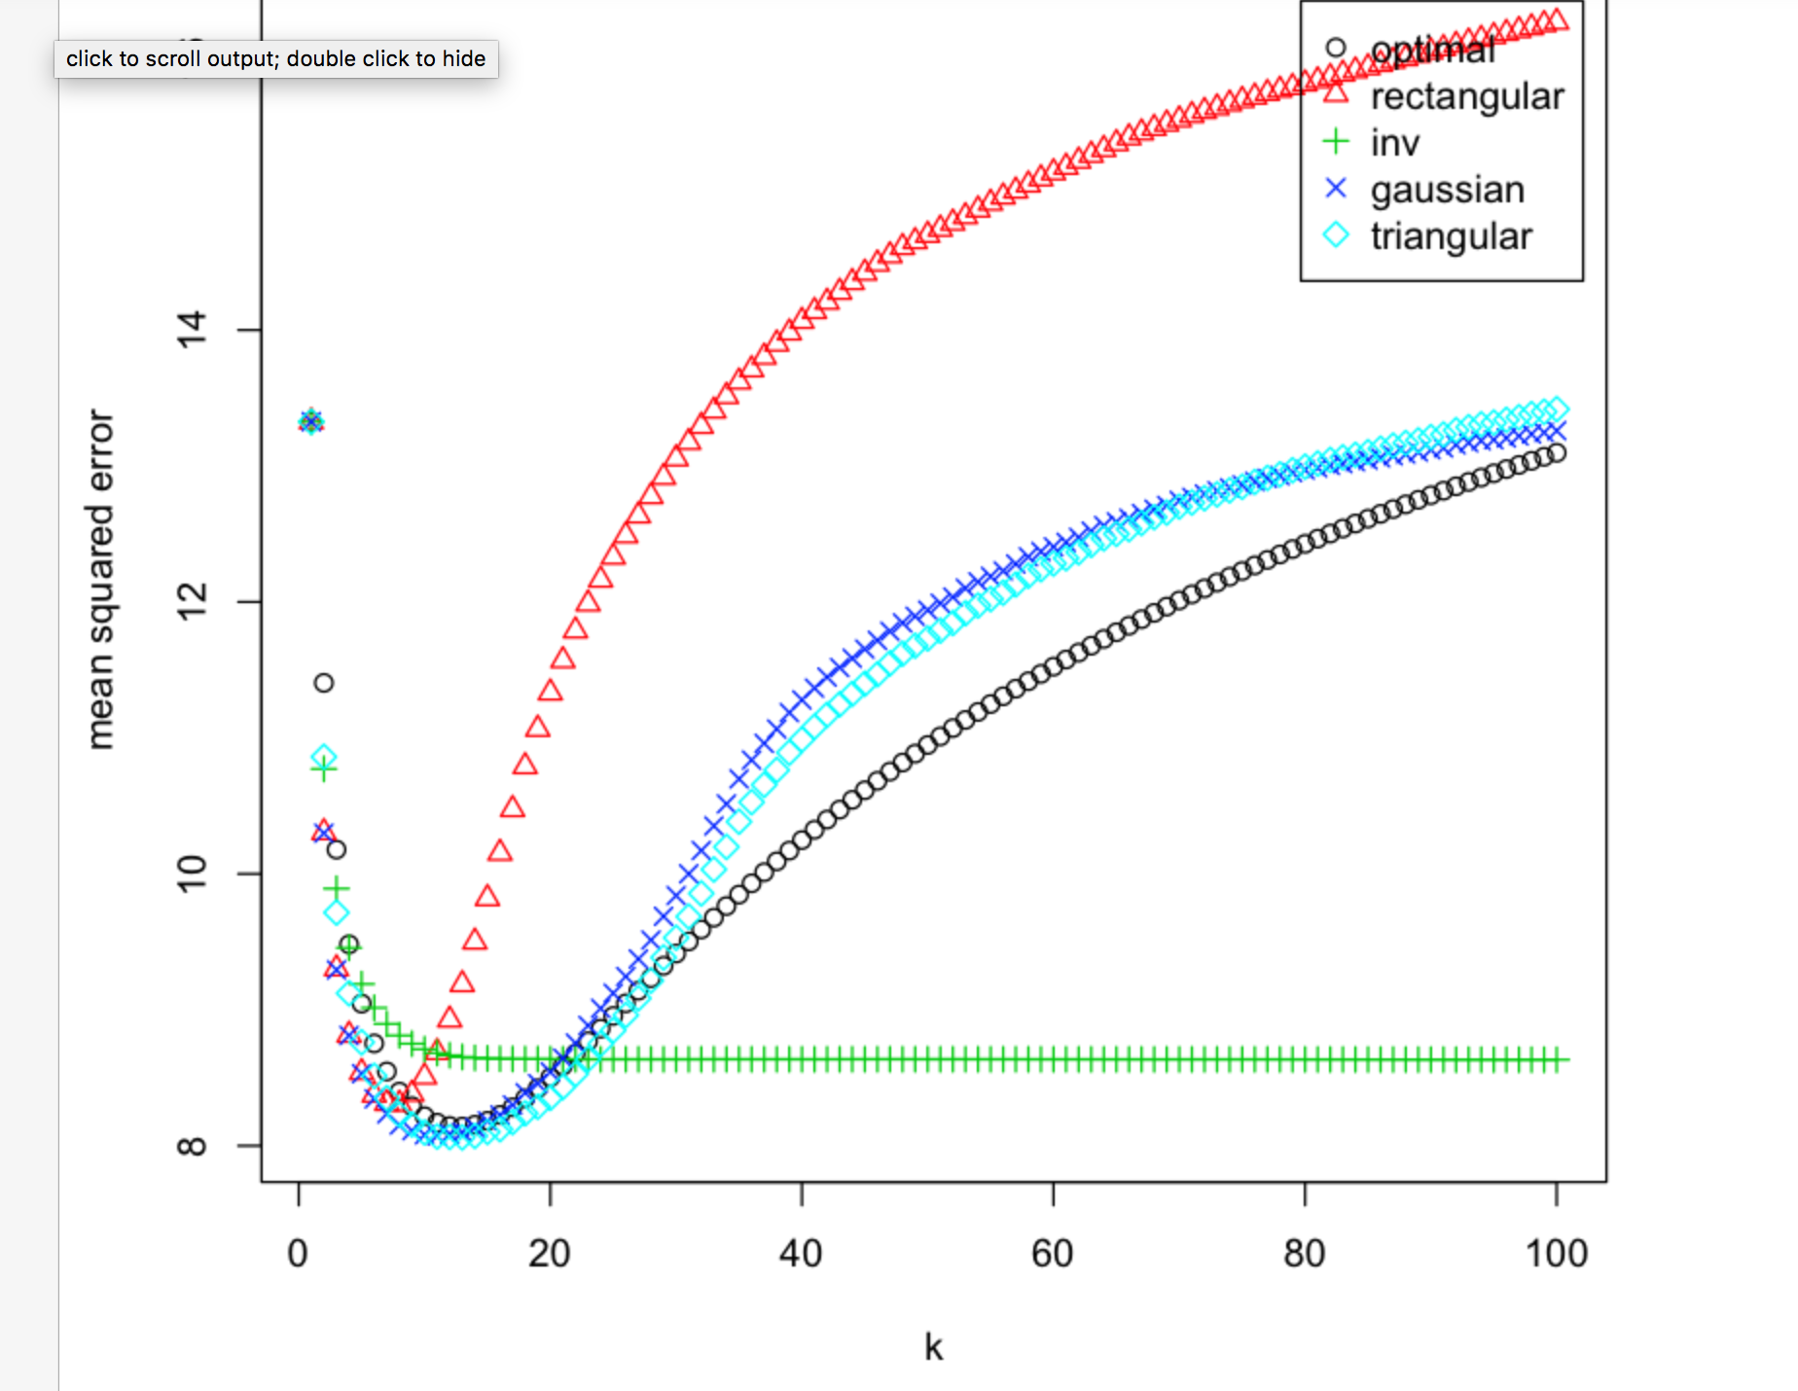

References
- Deborah Nolan and Duncan Temple Lang, “Case Studies in Data Science with R”. University of California, Berkeley and University of California, Davis. 2015. http://www.rdatasciencecases.org

